Patient Intake

Date: ____________ E-mail: ______________________________ Referred By: _____________________________________

Name: ________________________________________________ Birthdate: ______________________ Age: ____________

Home Phone: _______________________ Work Phone: ________________________ Cell Phone: ______________________

Address: __________________________________________ City: __________________ State: ______ Zip: ______________

SS #_______________________________________________________ Sex: □Male □Female

Occupation: ___________________________________ Employer/School: __________________________________________

□ Married □ Widowed □ Single □ Divorced □ Minor

Insurance Company Name: _____________________________________ Health Savings Account: Yes No

Secondary Insurance Company Name: ________________________________________________________________________

Spouse’s Name: ________________________________ Spouse’s Employer: ________________________________________

Have you ever received Chiropractic care? □Yes □No If so, When & Where? __________________________________

Have you ever received Physical Therapy services? □Yes □No If so, When & Where? ___________________________

Accident Information

Is condition due to an accident? □ Yes □ No Date: _______

Type of accident: □ Auto □ Work □ Home □ Other: ___________

To whom have you made a report of your accident?
□ Auto Insurance □ Employer □ Worker Comp. □ Other_______

Attorney Name (if applicable): ________________________________

Attorney Phone Number: _____________________________________

In Case of Emergency Contact:

Name: ____________________________________________

Relationship: _______________________________________

Home phone: (_____) ________________________________

Work phone: (_____) ________________________________

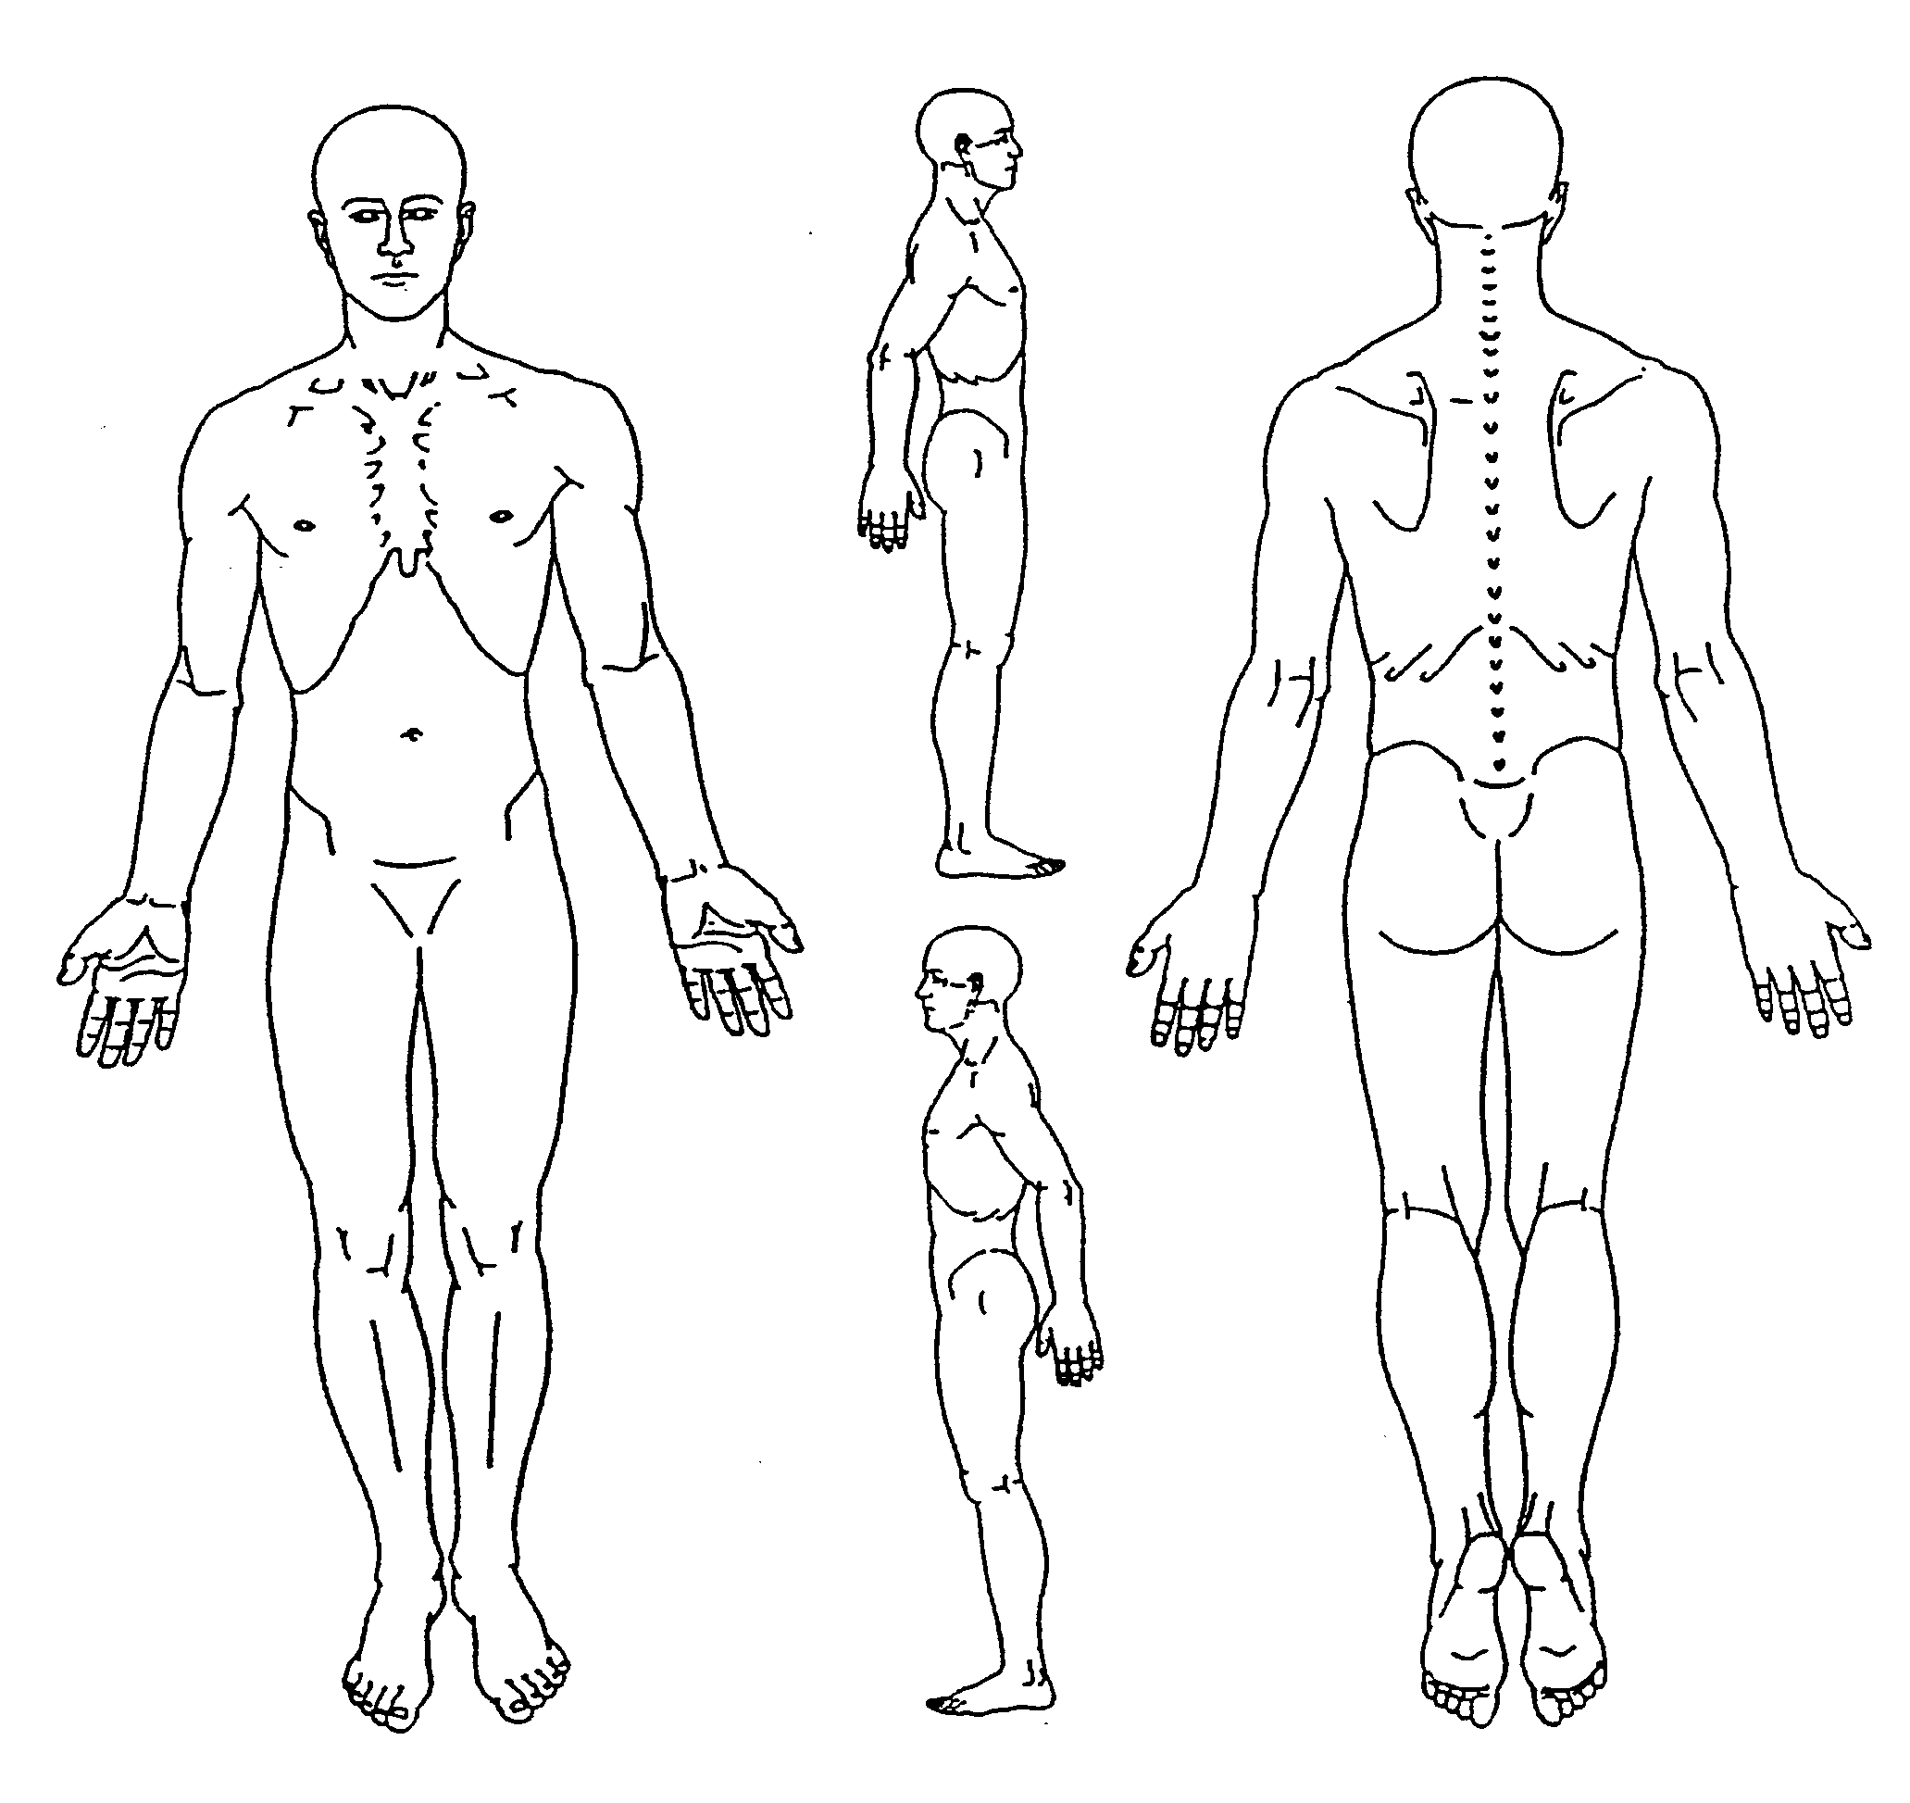
Patient Complaints
Please List all of the complaints/problems you would like the doctor to look at today. Mark an X on the picture for each problem. Please prioritize them from most important to least important. You will be given complaint forms for each problem listed to more thoroughly describe each problem.
1. ____________________________________________________________________
2. ____________________________________________________________________
3. ____________________________________________________________________
4. ____________________________________________________________________
5. ____________________________________________________________________

Health History
To help us rule out any conditions which might be aggravated by massage, please fill in all the appropriate information.

Are you currently being treated for any medical condition? Medical, chiropractic, physical therapy or other treatment? □ No □ Yes

If yes, who is treating you, what is/are the condition(s), how long have you been treated and how are you being treated?

Physician Condition How Long Type of Treatment
____________________ ___________________________ _____________ ______________________________________
____________________ ___________________________ _____________ ______________________________________
____________________ ___________________________ _____________ ______________________________________

Do you have a primary care physician? □ No □ Yes Name: _____________________________________________
Date of Last: Physical Exam: ______________ Spinal Exam: ______________
Spinal X-ray: ______________ Chest X-ray: ______________ MRI, CT, Bone Scan: ____________
Blood Test: ______________ Urine Test: ______________
Are you Pregnant? □ No □ Yes Due Date: _________________

Please mark on “Yes” or “No” to indicate if you have had any of the following:

1. AIDS/HIV □ Yes □ No 8. Epilepsy □ Yes □ No 15. Migraines □ Yes □ No
2. Arthritis □ Yes □ No 9. Fractures □ Yes □ No 16. MS □ Yes □ No
3. Bleeding □ Yes □ No 10. Gout □ Yes □ No 17. Osteoporosis □ Yes □ No
4. Cancer □ Yes □ No 11. Herniated Disk □ Yes □ No 18. Pacemaker □ Yes □ No
5. Diabetes □ Yes □ No 12. Metal Implants □ Yes □ No 19. Pinched Nerve □ Yes □ No
6. Prosthesis □ Yes □ No 13. R A □ Yes □ No 20. Stroke □ Yes □ No
7. Tumors □ Yes □ No 14. Growths □ Yes □ No 21. Other □ Yes □ No

If “Yes”, please write the number of the condition and explain when it was diagnosed and how it was treated
# When you had it & How it was treated Additional explanation
____ _____________ ____________________ _________________________________________
____ _____________ ____________________ _________________________________________
____ _____________ ____________________ _________________________________________
____ _____________ ____________________ _________________________________________
____ _____________ ____________________ _________________________________________
Habits
Tobacco □ Regularly □ Rarely □ Never Explain_____________________________________________________________
Alcohol □ Regularly □ Rarely □ Never Explain_____________________________________________________________
Caffeine □ Regularly □ Rarely □ Never Explain_____________________________________________________________
Exercise □ Regularly □ Rarely □ Never Explain_____________________________________________________________
High Stress □ Regularly □ Rarely □ Never Explain_____________________________________________________________

Would you be interested in additional information on any of the following?
□ Nutrition □ Exercise/Stretching □ Work Station □ Other _____________________________________________

Work Activity Medication/Supplements
What do you do for work: _______________________________ _____________________________For:_____________________
□ Sitting □ Standing □ Computer □ Repetitious tasks _____________________________For:_____________________
□ Lifting □ Weird postures □ Light labor □ Heavy labor _____________________________For:_____________________
_____________________________For:_____________________
Is your desk set up ergonomically? □ No □ Yes _____________________________For:_____________________
Do you take breaks? □ No □ Yes
Is your job stressful? □ No □ Yes Why?____________________ Allergies: ________________________________

Injuries/Surgeries you have had Description Date
Falls _____________________________________________________________________________ __________
Head injuries _____________________________________________________________________________ __________
Broken Bones _____________________________________________________________________________ __________
Dislocations _____________________________________________________________________________ __________
Surgeries _____________________________________________________________________________ __________
_____________________________________________________________________________ __________
Car accidents _____________________________________________________________________________ __________

Patient Name: Date:

Health History
To help us rule out any conditions which might be aggravated by massage, please fill in all the appropriate information.

Are you currently being treated for any medical condition? Medical, chiropractic, physical therapy or other treatment? □ No □ Yes

If yes, who is treating you, what is/are the condition(s), how long have you been treated and how are you being treated?

Physician Condition How Long Type of Treatment
____________________ ___________________________ _____________ ______________________________________
____________________ ___________________________ _____________ ______________________________________
____________________ ___________________________ _____________ ______________________________________

Do you have a primary care physician? □ No □ Yes Name: _____________________________________________ Date of Last: Physical Exam: ______________ Spinal Exam: ______________
Spinal X-ray: ______________ Chest X-ray: ______________ MRI, CT, Bone Scan: ____________
Blood Test: ______________ Urine Test: ______________
Are you Pregnant? □ No □ Yes Due Date: _________________

Please mark on “Yes” or “No” to indicate if you have had any of the following:
1. AIDS/HIV □ Yes □ No 6. Epilepsy □ Yes □ No 11. Migraines □ Yes □ No 16. Prosthesis □ Yes □ No
2. Arthritis □ Yes □ No 7. Fractures □ Yes □ No 12. MS □ Yes □ No 17. Rheumatoid Arthritis □ Yes □ No
3. Bleeding disorders □ Yes □ No 8. Gout □ Yes □ No 13. Osteoporosis □ Yes □ No 18.Stroke □ Yes □ No
4. Cancer □ Yes □ No 9. Herniated Disk □ Yes □ No 14. Pacemaker □ Yes □ No 19. Tumors/Growths □ Yes □ No
5. Diabetes □ Yes □ No 10.Metal Implants □ Yes □ No 15. Pinched Nerve□ Yes □ No 20. Other_____________□ Yes □ No

If “Yes”, please write the number of the condition and explain when it was diagnosed and how it was treated
# When you had it How it was treated Additional explanation
____ _____________ ____________________ _____________________________________________________
____ _____________ ____________________ _____________________________________________________
____ _____________ ____________________ _____________________________________________________
____ _____________ ____________________ _____________________________________________________
____ _____________ ____________________ _____________________________________________________

Habits
Tobacco □ Regularly □ Rarely □ Never Explain_____________________________________________________________
Alcohol □ Regularly □ Rarely □ Never Explain_____________________________________________________________
Caffeine □ Regularly □ Rarely □ Never Explain_____________________________________________________________
Exercise □ Regularly □ Rarely □ Never Explain_____________________________________________________________
High Stress □ Regularly □ Rarely □ Never Explain_____________________________________________________________

Would you be interested in additional information on any of the following?
□ Nutrition □ Exercise/Stretching □ Work Station □ Other _____________________________________________

Injuries/Surgeries you have had Description Date
Falls _____________________________________________________________________________ __________
Head injuries _____________________________________________________________________________ __________
Broken Bones _____________________________________________________________________________ __________
Dislocations _____________________________________________________________________________ __________
Surgeries _____________________________________________________________________________ __________
_____________________________________________________________________________ __________
Car accidents _____________________________________________________________________________ __________

Medications/Supplements
_____________________________For:_____________________ _____________________________For:_____________________ _____________________________For:_____________________ _____________________________For:_____________________

Allergies: ___________________________________
____________________________________________
Work Activity
What do you do for work: _______________________________
□ Sitting □ Standing □ Computer □ Repetitious tasks
□ Lifting □ Weird postures □ Light labor □ Heavy labor

Is your desk set up ergonomically? □ No □ Yes
Do you take breaks? □ No □ Yes
Is your job stressful? □ No □ Yes Why?____________________

Allergies

